Dr. Sylvia Bailey Shurbutt Knutti 223, 876-5207; Office Hrs.: M-R Appt.
Email @ Sshurbut@shepherd.edu , http://www.shepherd.edu/englweb/shurbutt.htm
English Department Webpage @ http://www.shepherd.edu/englweb/; Sakai @ http://courses.shepherd.edu/xsl-portal
Travel Page @ http://webpages.shepherd.edu/sshurbut/travelcourse1.htm
Celtic Roots, APST 430
View of the North Bridge and north elevation of Edinburgh’ s Old Town

PURPOSE AND DESIGN OF THE COURSE: The Celtic Roots course is the cornerstone of any Appalachian Studies experience, designed to expose students to the Celtic heritage associated with Appalachia, through literature and through travel— specifically travel to Scotland and Ireland. An array of Appalachian and Scot-Irish writers who influenced them will be explored through the literature. Midway through the course students will travel to Britain to explore Joyce’s Dublin, Scott’s Edinburgh, Burns’ Alloway, Synge’s Isle of Man, Hopkins’ Stonyhurst, Ron Rash’s Wales, Yeats’ Castle Coole, and others—in a land rich with love of language and storytelling that was inspiration to all Appalachians.
Ring of Kerry, Ireland 
TEXTS: Norton Anthology of British Literature, J. M. Synge’s Playboy of the Western World (Norton, 1995, 0-393-90072-X), James Joyce’s Dubliners (Penguin, 0-14-018647-6), Shakespeare’s Macbeth (Signet Classic, 0-451-52677-5), Walter Scott’s Rob Roy (signet Classic, 0-451-52623-6), Ron Rash’s Serena, Arthur Conan Doyle’s Sherlock Holmes Reader (Running Press), Terry Kay’s Bogmeadow’s Wish (Mercer UP, 978-0-88146-230-2), Anthology of Appalachian Writers, Ron Rash Volume IV (Shepherd UP)
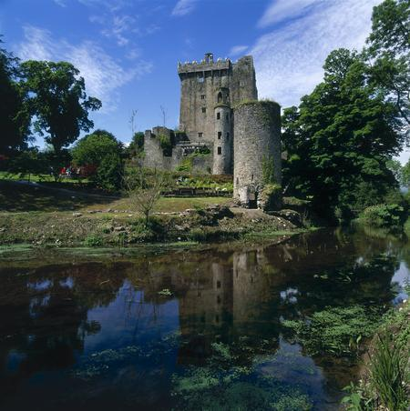Blarney Castle, Ireland
CONTENT:
Heather, Hills, and the Streets of Dublin:
1/8: Introduction
1/10, 15: Ireland’s Reluctant Hero: Jonathan Swift’s "A Modest Proposal," "A Meditation upon a Broom-stick,” Gulliver’s Travels
1/17: Celtic Twilight and Irish Nationalism: William Butler Yeats’ "The Lake Isle of Innisfree," "When You Are Old," "The Wild Swans at Coole," "A Coat," "Easter 1916," "Sailing to Byzantium"
1/22, 24: Playwright of the Irish World: J. M Synge’s Playboy of the Western World
1/29, 31, 2/5: Leopold Bloom in the City: James Joyce’s Dubliners
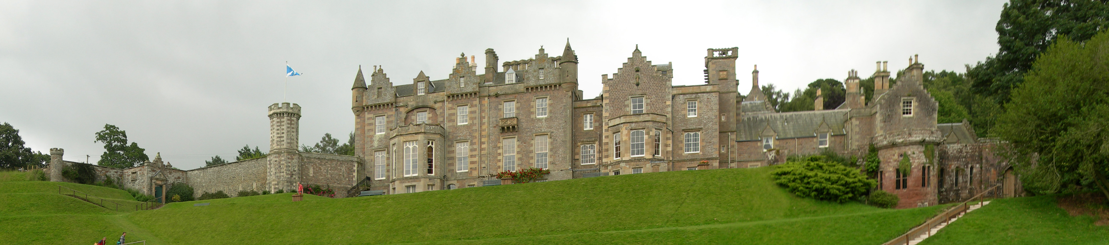Sir Walter Scott’s Abbotsford
Scottish Lairds and Highland Vales:
2/7: Dunedin’s Dark & Doom: William Shakespeare’s Macbeth 2/12, 14: A Celtic Twilight in Wales: Ron Rash’s Welsh Poems from the Mabinogian and Serena 2/19, 21: Rhythms Sprung from the Soul: Gerard Manley Hopkins & Robert Morgan
2/26, 28: Sonnets and Satire from Highland Farmer Poets: Jesse Stuart’s Greenup County Poems and Robert Burns’ "Holy Willie’s Prayer," "To a Mouse," "My Luve Is Like a Red, Red Rose," "Highland Mary," "Scots Wha Hae," "Tam O’Shanter"
3/5: Bravehearts and Bonnie Lads: Walter Scott’s Rob Roy
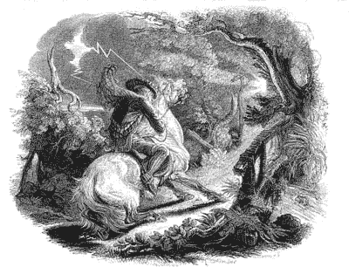 Tam O’Shanter by Burns
3/7: Test #1, Essay #1.
3/8 – 3/19 Celtic Roots Study Tour of Ireland, Scotland and Wales
Moors, Mists, and Celtic Trails:
3/21, 26, 28: A Dark within the Victorian Soul: Bram Stoker’s Dracula
4/2, 4, 9 : Moriarty’s Nemesis: Sir Arthur Conan Doyle’s Sherlock Holmes 4/9: Travel Practicum Abstracts & Journals Due
4/16, 18: A Poetic Feast in Wales: Seamus Heaney and Dylan Thomas
4/23, 25: A Feast of Appalachian Poems & Tales: Anthology of Appalachian Writers, Ron Rash Volume IV
4/30: An Appalachian’s Irish Road-trip: Terry Kay’s Bogmeadow’s Wish
5/4: Test 2 Essay 2 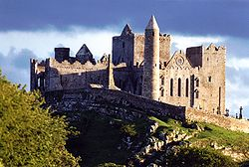Rock of Cashel
EVALUATION:
All reading assignments must be completed by the posted dates above, and a number of reading analyses will be administered throughout the semester in order to ascertain the depth of student critical reading and thinking skills. A minimum of two formal literary essays will also be written; essay grades will be factored into the test and exam scores and must be revised as directed before the assignment is complete. Class participation is considered an important part of the course, both in class and on Sakai, and students are expected to participate. The average of reading analyses/class and Sakai discussions (each student must have a minimum of 5 substantive Sakai posts), test 1, and test 2 grades will be factored together according to the following scale: 1/3, 1/3, 1/3. PLAGIARISM (using another's words or ideas without proper crediting) will result in a zero on the assignment, potential failure of the course and expulsion from the University—see the University policy on plagiarism (page 154 of the Student Handbook, accessible at http://www.shepherd.edu/students/studenthandbook.pdf). All incidences of plagiarism are required to be reported to Dave Cole, the Assistant Dean of Students; cheating may result in suspension. All assignments should be downloaded from Sakai, and students should regularly check the web discussion room (at least once or twice a week). Make-up work will be administered on a day set aside at the end of the semester and allowed only if absences are excused; students should contact the professor in advance of an absence at sshurbut@shepherd.edu (or notify the English Department secretary, X-5220) and present a doctor's note if excuses are to be judged credible. Grades taken on a day when an unexcused absence has occurred will be recorded as 0. Cell phones should be turned off; texting is not allowed in class. All essays will be in multiple drafts, with a final, copy-ready draft required after teacher editing; students wishing feedback and assistance in writing essays should make an appointment in the Writing/Study Center, consult ShepOwl, or see the instructor prior to due dates; for information see http://www.shepherd.edu/ascweb/. Assignments utilize Wikipedia for the visual and introductory components of this online encyclopedia; Wikipedia should not be used as a bibliographic reference in essays since it is an encyclopedia and superficial in nature.

